Configuration and Implementation of Access Control Lists (ACL) Using Cisco Packet Tracer

A Project Based Learning Report Submitted in partial fulfilment of the requirements for the award of the degree

of

Bachelor of Technology
in The Department of ECE
Network Protocols and Security(24EC2210)

Submitted by
2410040034: VARUN
2410040023: SOHAM
2410040029: PAVAN
2410040032: KARTHIKEYA

Under the guidance of
Prasanna Lakshmi Akella



Department of Electronics and Communication Engineering
Koneru Lakshmaiah Education Foundation, Aziz Nagar
Aziz Nagar – 500075
APR - 2026.
Abstract

This project explains the concept and implementation of Access Control Lists (ACLs) using Cisco Packet Tracer in a simple and practical way. In computer networks, many devices are connected and communicate with each other by sending and receiving data. However, not all communication should be allowed, as it may lead to security issues or unauthorized access. Therefore, it becomes important to control the flow of network traffic, and this is where ACLs play an important role.
Access Control Lists are a set of rules that are configured on routers to permit or deny network traffic based on certain conditions. These conditions can include IP addresses, protocols, and port numbers. In this project, we mainly focus on Standard ACL, which filters traffic based on the source IP address. By using ACLs, we can decide which device is allowed to communicate and which device should be restricted.
In this project, a network is designed using Cisco Packet Tracer software. The network consists of a router, switches, and multiple PCs connected in two different networks. Each device is assigned a unique IP address to enable communication. The router acts as the central device that connects both networks and controls the traffic between them.
A specific condition is implemented in this project where one PC is restricted from accessing the second network, while all other devices are allowed to communicate normally. This is achieved by configuring an Access Control List on the router. The ACL is applied to the router interface so that it can filter the traffic passing through it. The rules are written in such a way that the selected device is denied access, and all other traffic is permitted.
After configuration, the network is tested using the ping command. The results show that the restricted device is unable to communicate with the other network, while the remaining devices can successfully send and receive data. This confirms that the ACL is working correctly and the traffic is being controlled as expected.
Overall, this project helps in understanding how network security can be improved using simple techniques like Access Control Lists. It also provides practical knowledge of configuring and testing networks using Cisco Packet Tracer. This project is useful for learning how real-world networks are managed and secured in an efficient manner.

List of Figures
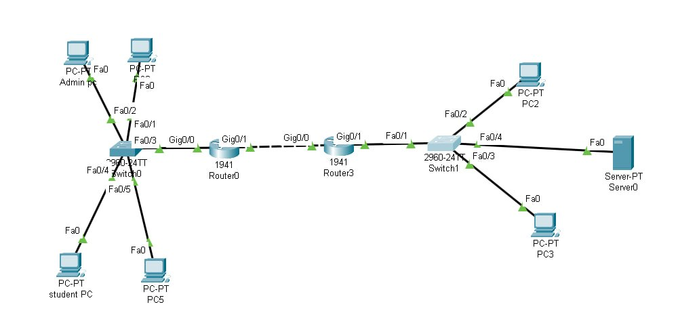
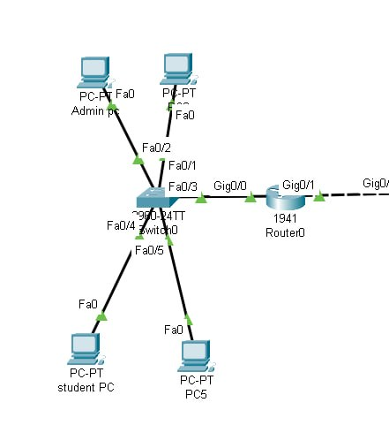

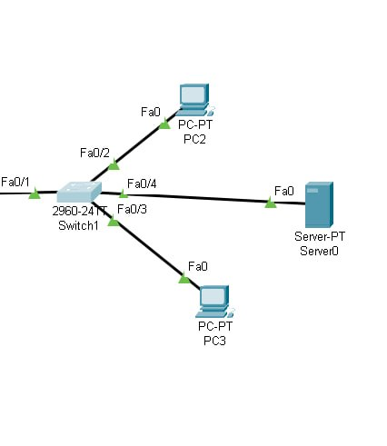

List of Tables

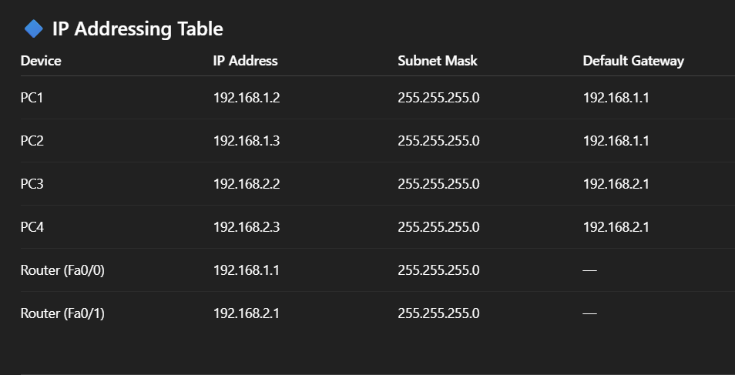

🔷 Notes
- PCs use the router interface IP as default gateway
- Router does not need a gateway in this simple network
- Same subnet devices share the same subnet mask

Configuration and Implementation of Access Control Lists (ACL) Using Cisco Packet Tracer Note: Maintain Document format as it is in terms of font size and font theme.

Introduction
- In today’s world, computer networks play a very important role in communication and data sharing. Devices such as computers, laptops, and servers are connected through networks to exchange information. As networks grow larger, it becomes necessary to manage and control the flow of data to ensure security, efficiency, and proper communication between devices.
- One of the major challenges in networking is preventing unauthorized access and controlling which devices are allowed to communicate with each other. Without proper control, networks may become vulnerable to security threats, misuse, and unnecessary traffic. To solve this problem, network administrators use various techniques, one of which is Access Control Lists (ACLs).
- Access Control Lists are a set of rules used in routers to filter network traffic. These rules determine whether a packet should be permitted or denied based on conditions such as IP addresses, protocols, and port numbers. ACLs help in improving network security by restricting unwanted access while allowing valid communication.
- In this project, Cisco Packet Tracer is used as a simulation tool to design and implement a network. It provides a virtual environment where networking concepts can be practiced without the need for physical hardware. The project focuses on configuring ACLs in a network consisting of multiple devices connected through a router.
- The main aim of this project is to understand how ACLs work and how they can be used to control network traffic. By applying ACL rules, specific devices can be restricted from accessing certain parts of the network, while others are allowed to communicate normally. The project also demonstrates how to test the configuration using basic commands like ping.
- Overall, this project provides a clear understanding of network traffic control and highlights the importance of security in computer networks using Access Control Lists.

METHODOLOGY
The project is carried out in a step-by-step manner using Cisco Packet Tracer. First, a network topology is designed by placing the required devices such as router, switches, and PCs. All the devices are then connected using appropriate cables.
Next, IP addresses, subnet masks, and default gateways are assigned to each device to enable communication within the network. After that, the router is configured by assigning IP addresses to its interfaces.
An Access Control List (ACL) is then created on the router to restrict traffic from a specific device. The ACL is applied to the appropriate interface to control the flow of data between networks.

RESULTS

After configuring the network and applying the Access Control List (ACL), the system was tested using the ping command to verify communication between devices.
The results show that the ACL is working correctly as per the given condition. The specific device (PC1), which was restricted using the ACL, was unable to communicate with devices in the second network. The ping requests from this device failed, indicating that the traffic was successfully blocked.
At the same time, other devices in the network, such as PC2, were able to communicate with devices in the second network without any issues. The ping requests from these devices were successful, showing that normal traffic was allowed.
These results confirm that the ACL effectively controls network traffic by denying access to specific devices while permitting others. The project successfully demonstrates how ACLs can be used to improve network security and manage communication between networks.
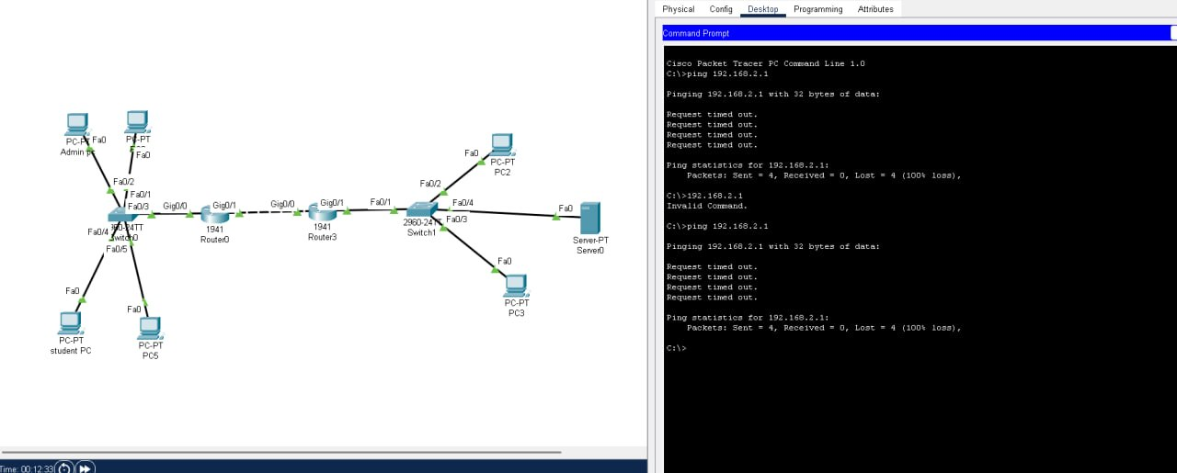

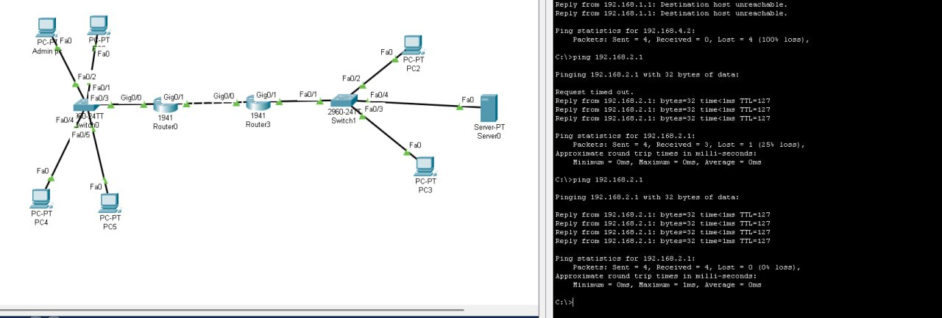

CONCLUSION and FUTURE WORK
In this project, we successfully designed and implemented a network using Cisco Packet Tracer and configured Access Control Lists (ACLs) to control network traffic. The ACL was applied on the router to restrict communication from a specific device while allowing other devices to communicate normally.
The results showed that the configured rules worked as expected. The restricted device was unable to access the target network, while the remaining devices could communicate without any issues. This demonstrates how ACLs can be effectively used to improve network security and manage traffic flow.
Overall, this project helped in understanding the practical implementation of ACLs and their importance in protecting networks from unauthorized access.

References
• Cisco Networking Academy, Introduction to Packet Tracer, Cisco Systems
• Cisco Systems, Access Control Lists (ACL) Configuration Guide
• Behrouz A. Forouzan, Data Communications and Networking, McGraw-Hill Education
• Andrew S. Tanenbaum, Computer Networks, Pearson Education
• Cisco Packet Tracer Software (Simulation Tool)
• Online tutorials and documentation on networking concepts and ACL configuration

